***MotoGP – part 5***

We give our *MotoGP* application the latest features. We create a page to view the data of the races. We program an admin page to manage the ticket payments. We will end with a page to view the teams and pilots.

***1. Search Races***

List all races. At the bottom of this page you will see a hyperlink *One by one,* we haven't programmed yet:

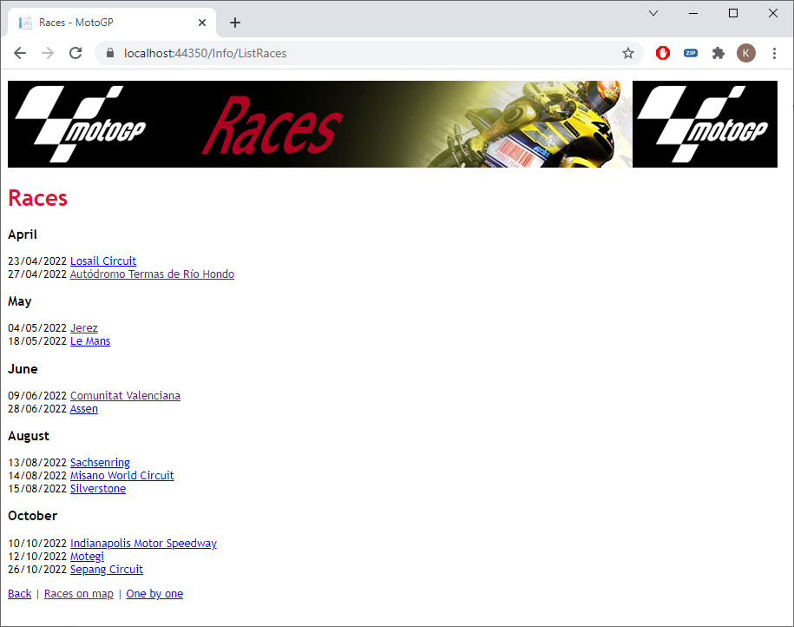

If you click on it, it will take you to the *SelectRace* method of the *Info* controller. Create that method with an associated view, so that you can query the races with a *selectlist*. The first time you get:

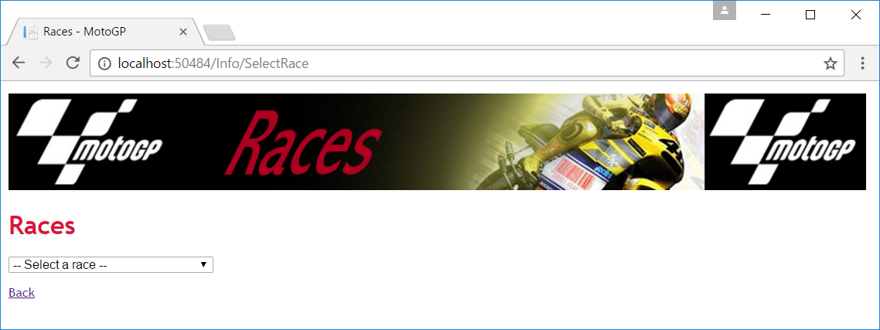

Then select a race:

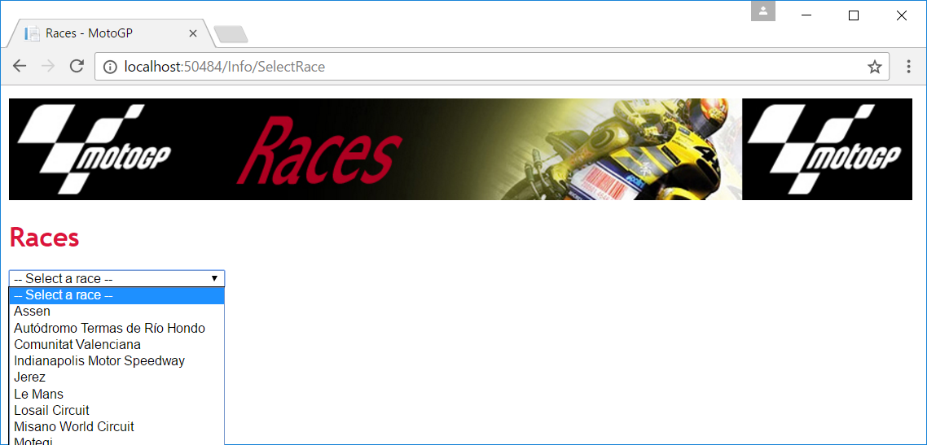

You will then immediately see the data of the selected race:

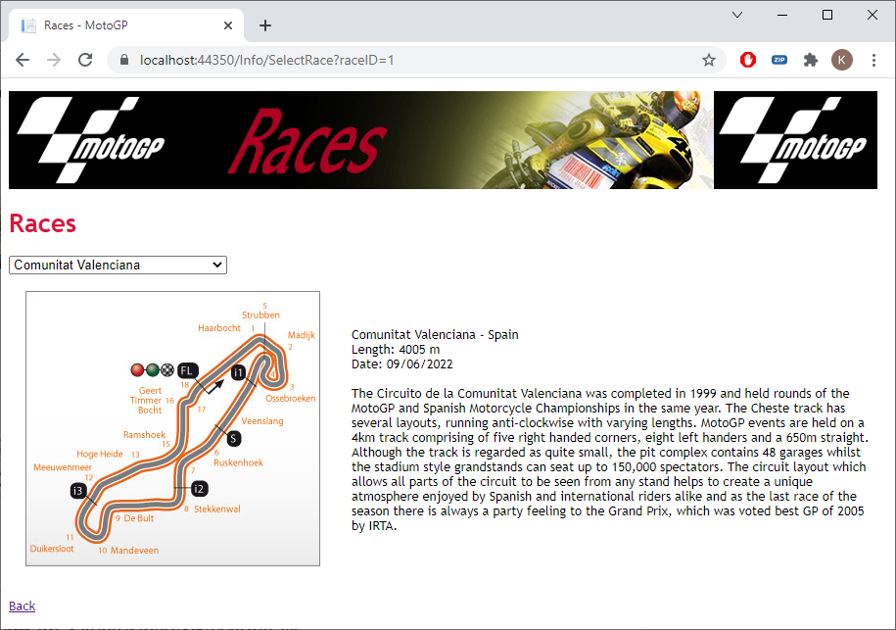

Tip: You will also need a *ViewModel*. Call this *SelectRaceViewModel.cs*.

***2. Admin-menu***

Customize the main menu of the application and provide an *admin hyperlink* in the lower left corner. If you click on it, jump to the *ListTickets* method of the *Shop* controller. For now, the hyperlink is accessible to everyone. We'll see how to secure your website later in the course. You will get (the hyperlink may not be visible until you have also created the method in the controller):

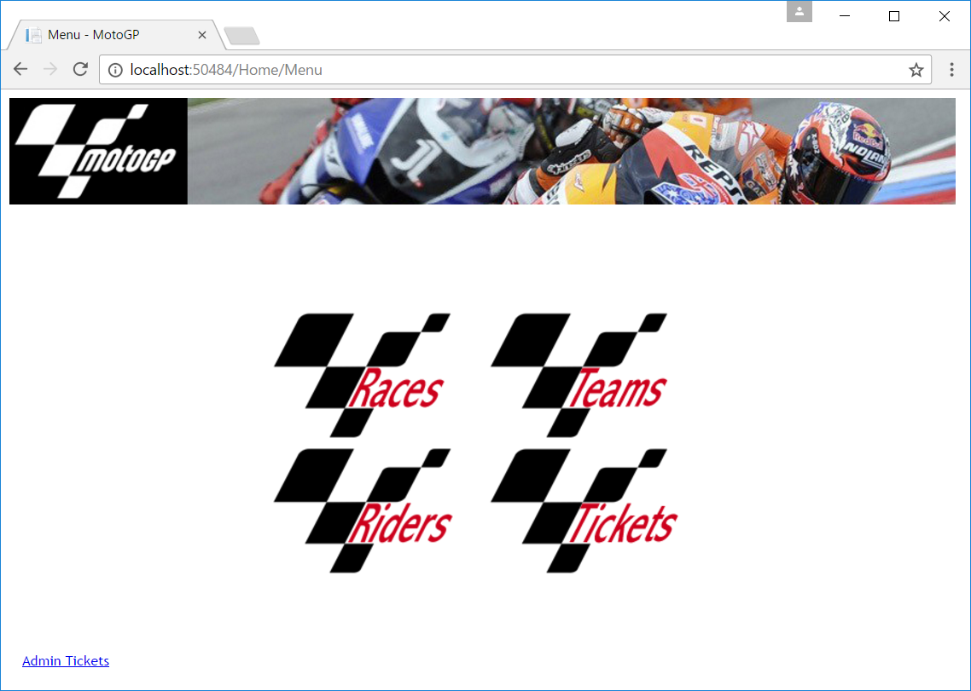

***3. List tickets***

Now code the *ListTickets* method with an associated view so that the administator can view all the ordered tickets. Provide a *selectlist* to select a race. Of course you need a *ViewModel* (ListTicketsViewModel.cs). If you go to the page from the menu, you get all the tickets. The most recent order will be at the top:

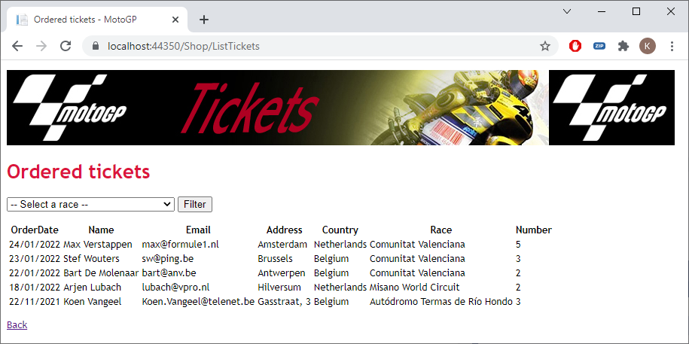

You can now use the *selectlist* to select a race and you will only get the tickets for that race:

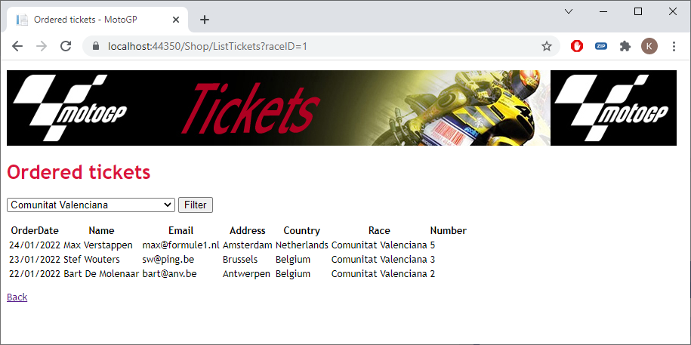

If there are no ordered tickets for that race, you will get:

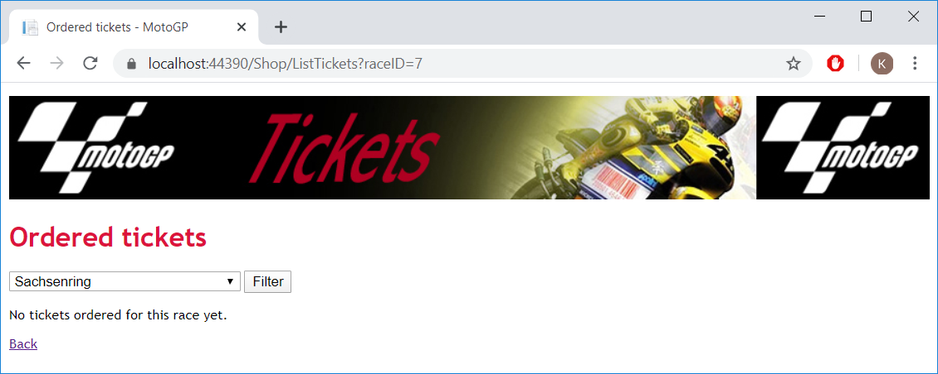

***4. Register payments***

First modify the list of tickets as follows:

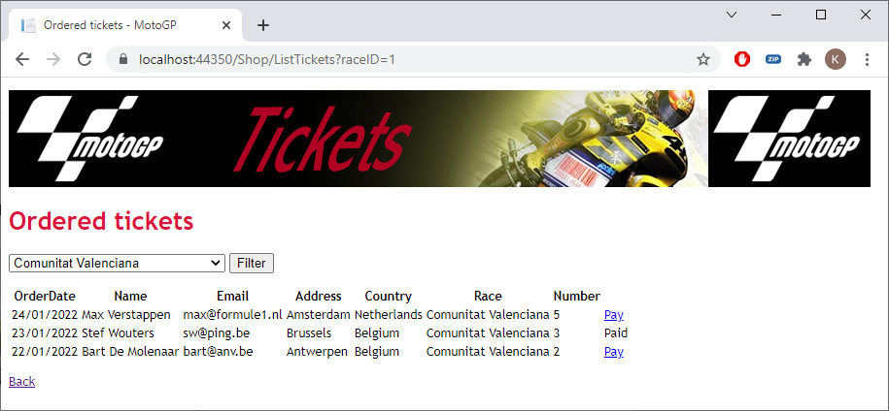

The paid tickets show the text *Paid*. If the tickets are not yet paid, you get a hyperlink *Pay*. This takes you to the *EditTicket* method of the *Shop* controller. You pass the *TicketId* as parameter.

Now program the page below to register a payment:

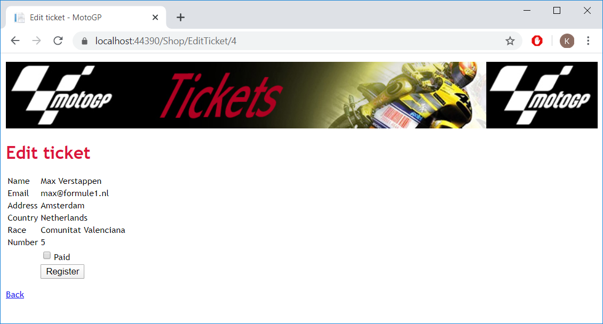

And after clicking on *Register*:

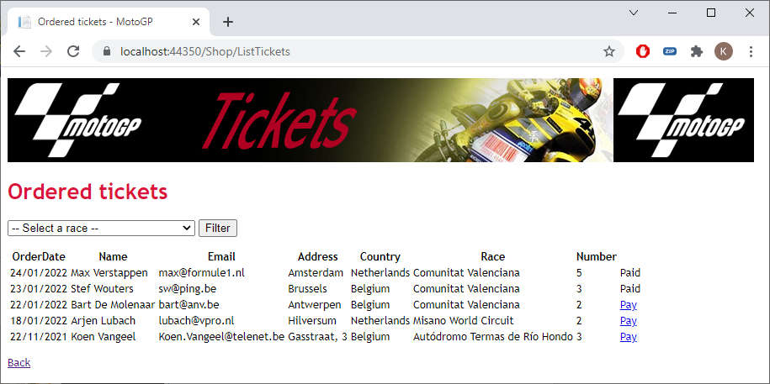

***5. Teams***

Give the *Info* controller a *ListTeams* method. Also provide a view so that you get the following result:

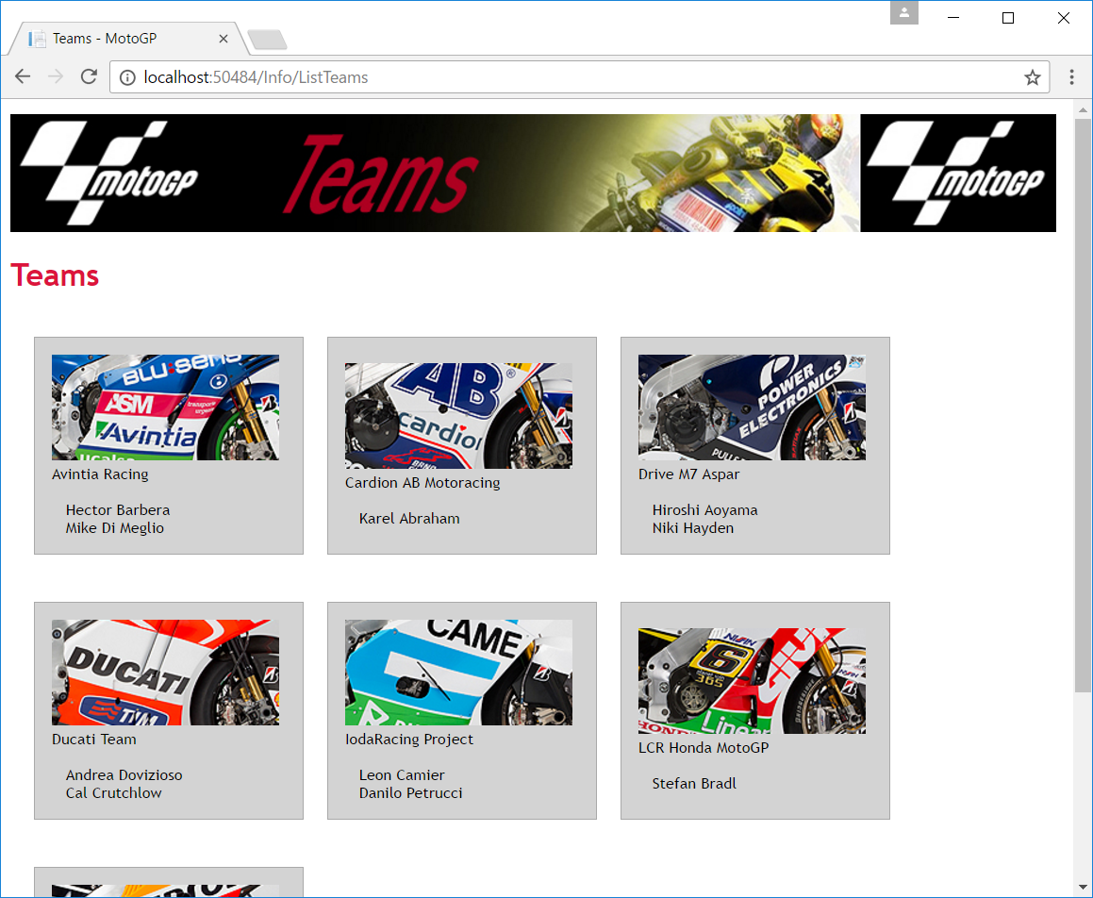

The page shows an overview with all the teams and for each team the pilots who ride for it. You show three teams in every row.

***6. Teams and riders***

In the *ListTeams* view, create a *Teams & Riders* hyperlink that points to */Info/ListTeamsRiders*:

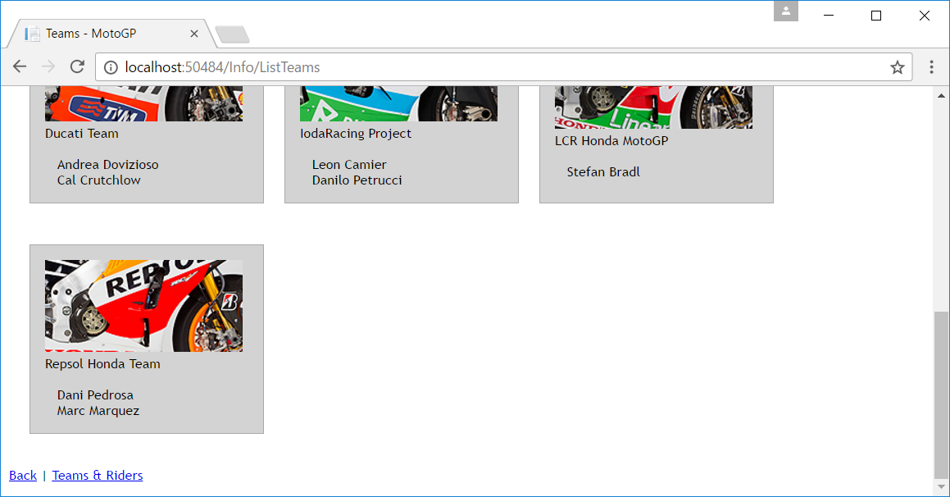

Create a final method *ListTeamsRiders* in the *Info* controller. Also create a *View* and a *ViewModel*. When you call the page for the first time, you get:

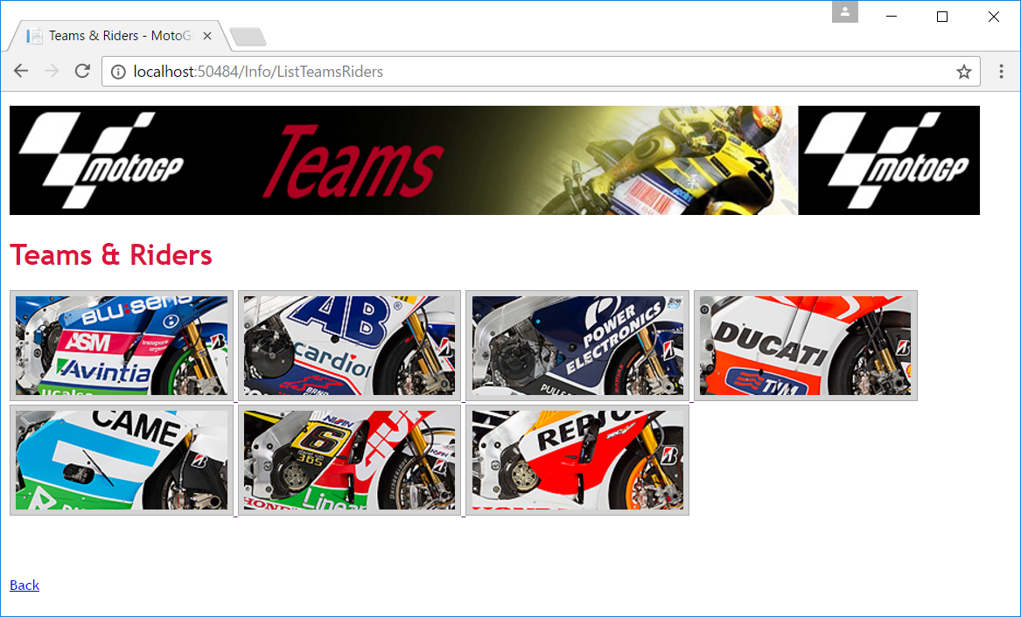

You will see a list of all team logos. If you click on such a logo, you will see all pilots of that team below it. For example for *Repsol*:

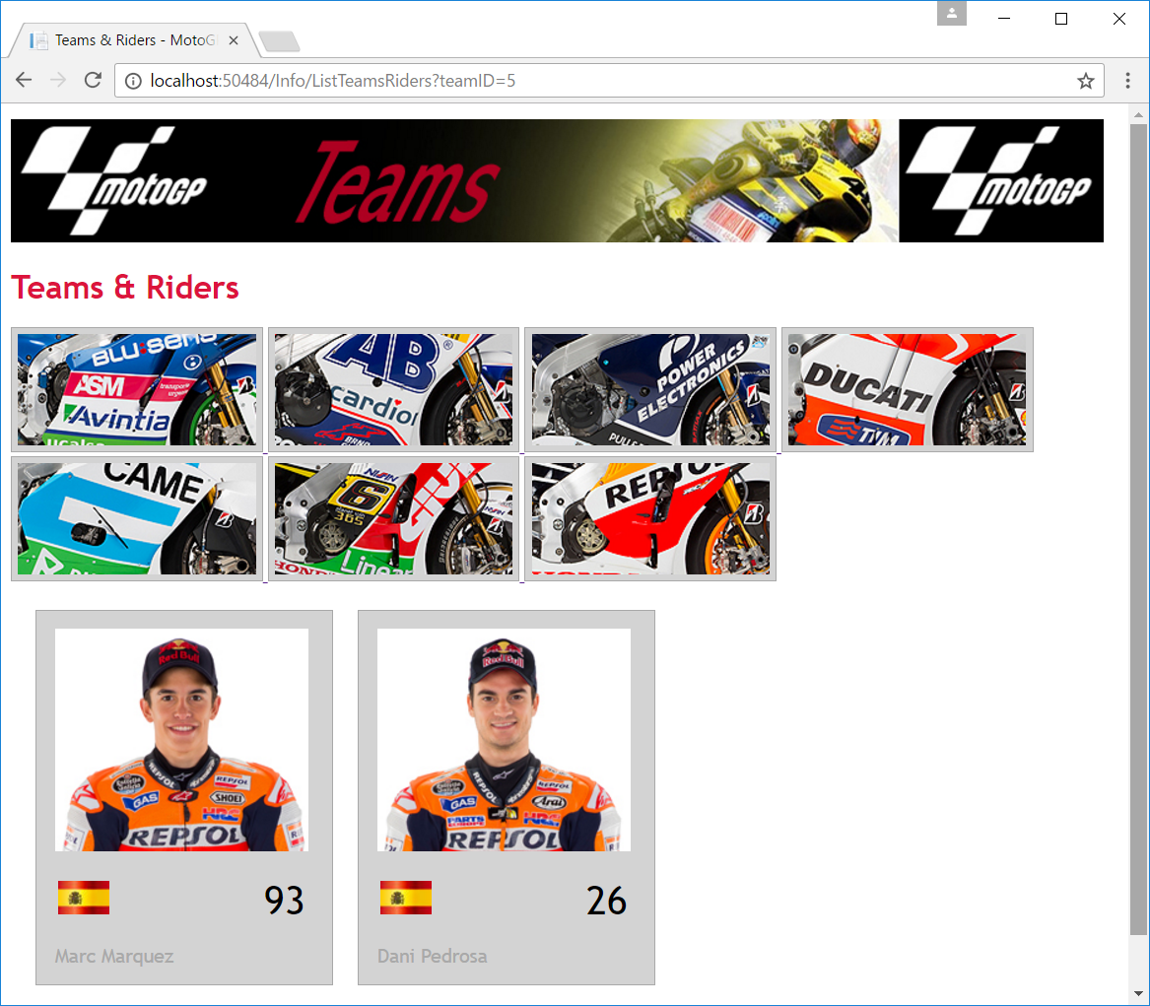

***7. A final test***

All hyperlinks should work now. Try out the whole application again! Congratulations!